**Concepts**

1. Suppose you fit a model, *f*(*X*) = β0 + β1*X*1 + β2*X*2 + β3(*X*1*/X*2)

(a) For a fixed value of *X*2 = *c*, what is the “slope” of *X*1 (i.e., how much does *f*(*X*)

change for a 1-unit change in *X*1)? **Write the answer in terms of parameters and** *c***.**

**->** f(X) = β0 + X1(β1 + β3/X2) + β2X2

-> β1 + β3/c

(b) For a fixed value of *X*1 = *d*, what is the “slope” of *X*2 (i.e., how much does *f*(*X*)

change for a 1-unit change in *X*2)? **Write the answer in terms of parameters and** *d***.**

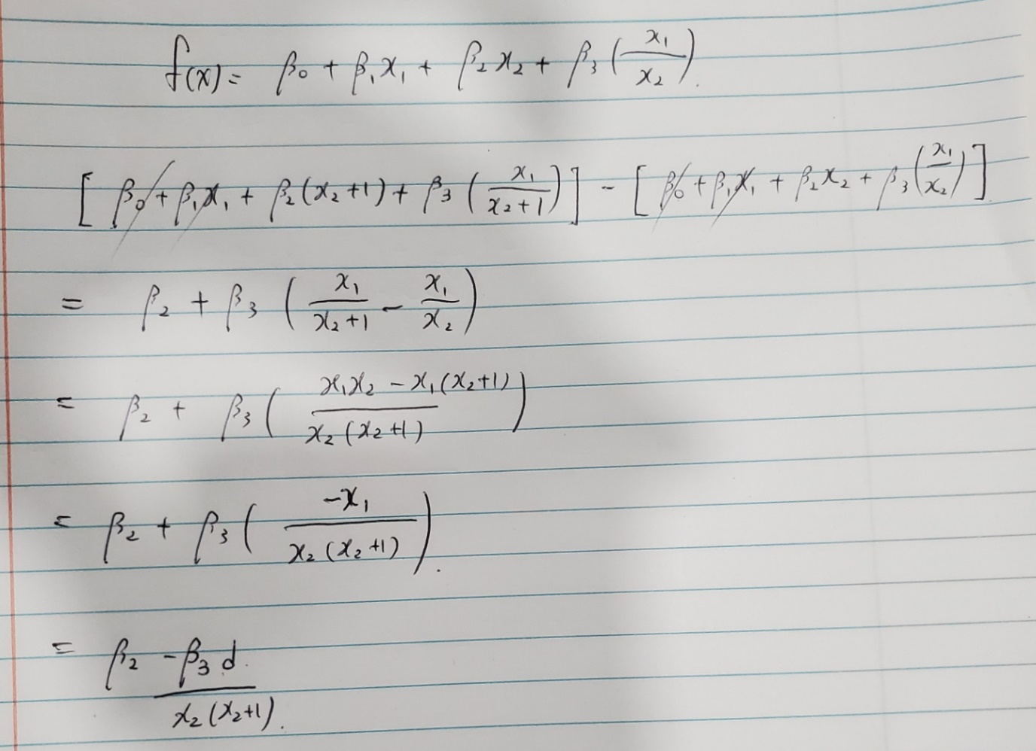

1. Suppose that *X* is numerical and *Z* is categorical (factor) with two levels. Someone has shown you a model where they fit lm(Y~X + Z + X:Z).**Write the model that R fits**

**as a single regression model of the form** *f*(*x*) = *...***.** Use variables *zq, q* = 1*, . . . , Q,*

to represent indicators for level *q* of *Z*

